

# User Manual

Version 1.0

17/04/2024

Table of Contents

1. Introduction 3

1.1 Overview 3

2. Getting Started 4

2.1 Cautions & Warnings 4

2.2 Set-up Considerations 4

3. Using the System 5

3.1 Accessing The Website 5

3.2 Exploring Categories 5

3.3 Viewing Post 5

3.4 Creating a Post 5

3.5 Learning About the Website 6

## Introduction

Welcome to the User Manual for MakerMingle, your ultimate online destination for all things DIY! This manual provides comprehensive guidance on how to navigate and utilize the various features of our website effectively. Whether you're here to explore new DIY projects, share your own creations, or connect with fellow DIY enthusiasts, this manual will ensure you get the most out of your experience. Get ready to unleash your creativity with MakerMingle!

### Overview

* **Home Page:** The Main Page is your starting point, featuring a login/signup pop-up and quick links to explore DIY projects across various categories.
* **About Page:** Learn about the mission, vision, and creators of MakerMingle, understanding the community and its values.
* **Explore Page:** Browse DIY projects categorized by themes such as Home Decor, Gardening, and more, finding inspiration and ideas for your next project.
* **Post Page:** View all projects within a selected category here. Logged-in users can also add their own projects to share with the community.

## Getting Started

**Home**

* Visit MakerMingle to access the main page. Use the login/signup pop-up to create a new account or enter your credentials to log in.
* Utilize the navigation bar to access different sections like Explore and About.
* You can also toggle between light and dark mode from the navigation bar to suit your viewing preference.

**Explore**

* Click on the 'Explore' tab from the main page to view the different DIY categories.
* Select any category to view the associated DIY projects.

**Posts**

* After selecting a category on the Explore Page, you'll be directed to the Posts Page where you can browse all projects in that category.
* Click on any project to view its details or click ‘Create Post’ to start sharing your own project.
* Scroll through the project details, and if logged in, use the comment section at the bottom to engage.

**Create Post**

* Click ‘Create Post’ on the Posts Page. You must be logged in to access this feature.
* Fill in the project details and upload image.

**About**

* Access the About Page via the navigation menu to learn more about the website and its creators.
* Read through various sections detailing the website's purpose, history, and team.

### Cautions & Warnings

* Ensure your internet connection is stable to avoid disruptions while browsing or uploading content.
* Verify that any images or content uploaded do not infringe on copyright laws.
* Be cautious of sharing personal information in posts or comments that could be used maliciously.

### Set-up Considerations

* The website is best viewed on recommended browsers e.g., Chrome, Firefox, Safari with JavaScript enabled.
* Ensure accurate information is provided during account creation for a smoother experience with features such as project posting and commenting.

## Using the System

Welcome to the practical guide on navigating and utilizing MakerMingle. This section provides detailed, step-by-step instructions on how to effectively use all the features of our website. From logging in and exploring DIY categories to creating your own posts and interacting with other users, these guidelines will help you seamlessly engage with the content and community. Each step will be accompanied by illustrative screenshots to ensure clarity and ease of use. Whether you're a first-time visitor or a returning user, these instructions are designed to enhance your experience on our platform. Let’s get started!

### Accessing The Website

**Step 1**: Open your preferred web browser and enter the URL of MakerMingle in the address bar.

**Step 2:** Press Enter to load the website. The Main Page will appear.

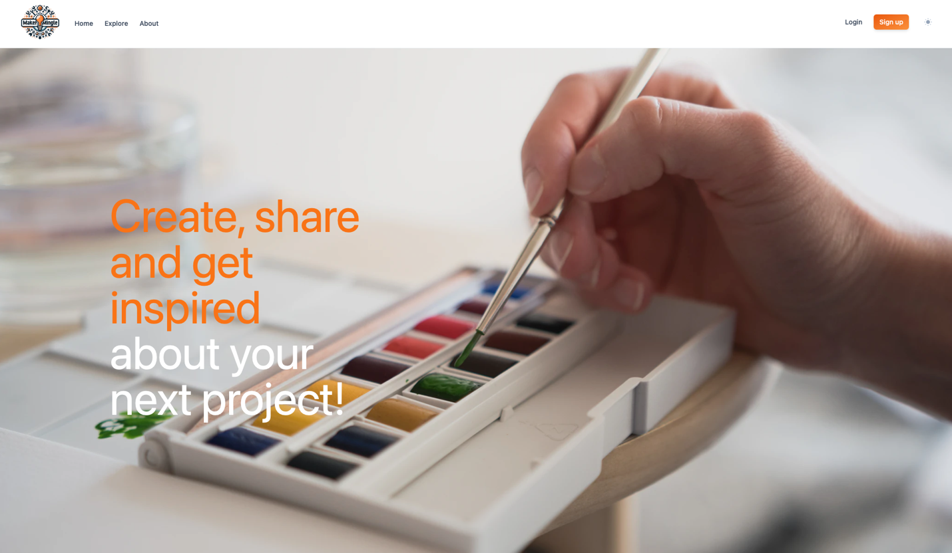

**Logging In/Signing Up:**

**Step 1:** On the Main Page, click on the 'Login/Signup' button located in the navigation bar.

**Step 2:** If you're a new user, fill in the required fields under 'Sign up' (e.g., email, username, password) and submit the form. If you are returning, enter your login credentials under 'Login'.

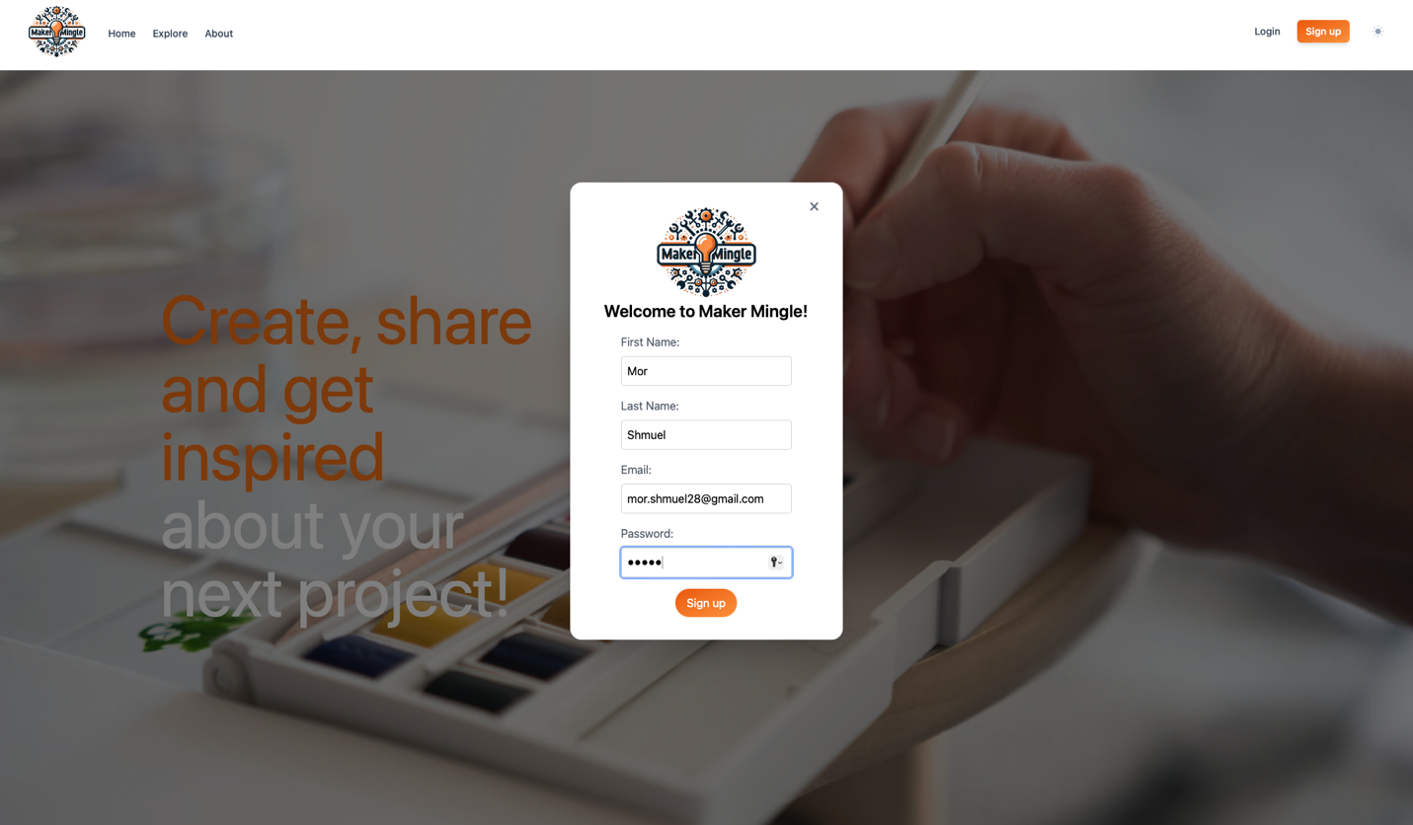

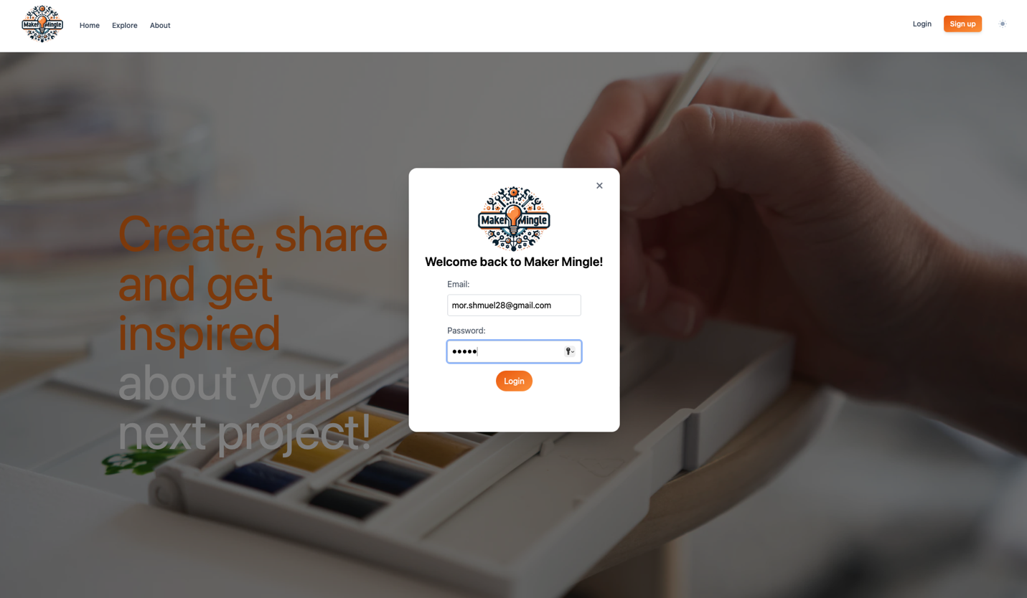

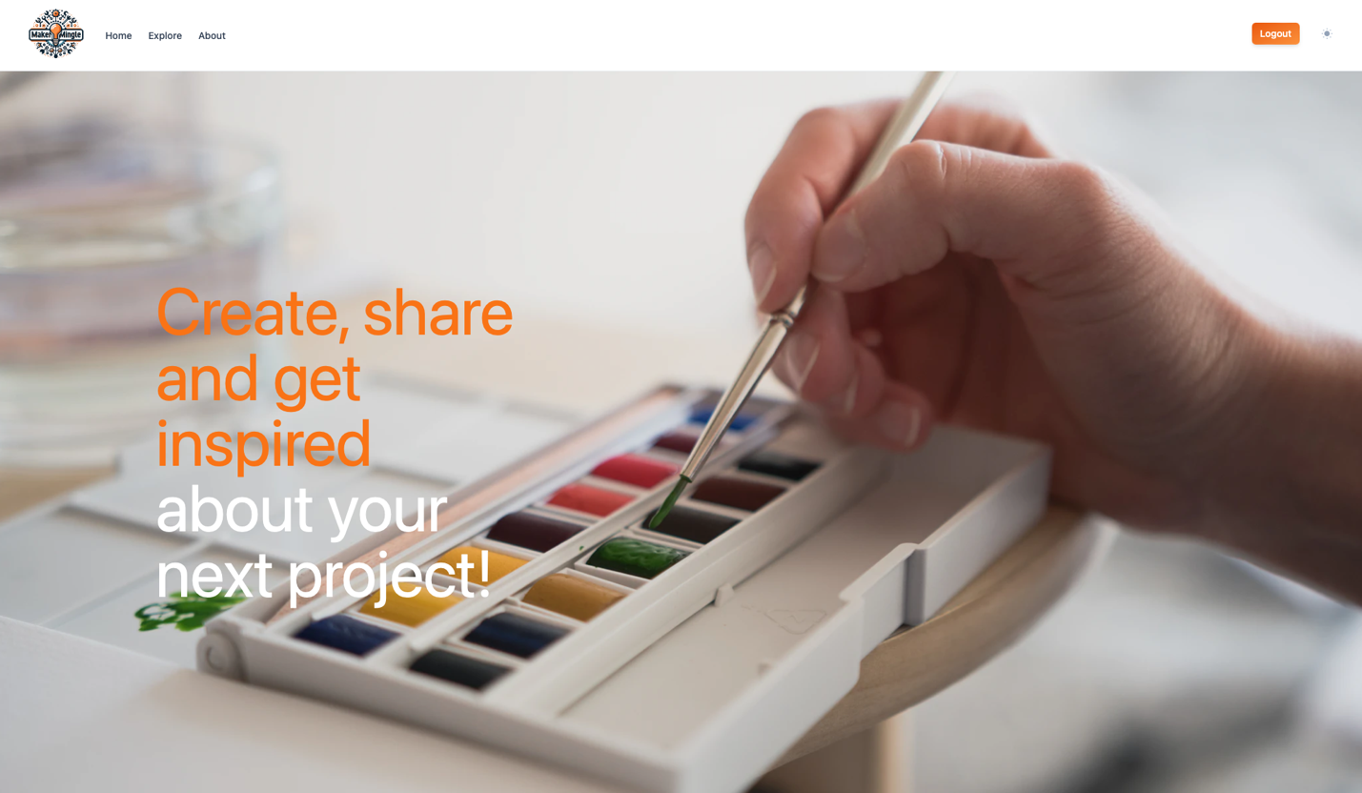

**Toggling Dark Mode:**

**Step 1:** Locate the 'Dark Mode' toggle in the navigation bar.

**Step 2:** Click the toggle to switch between light and dark mode. The page theme will change immediately.

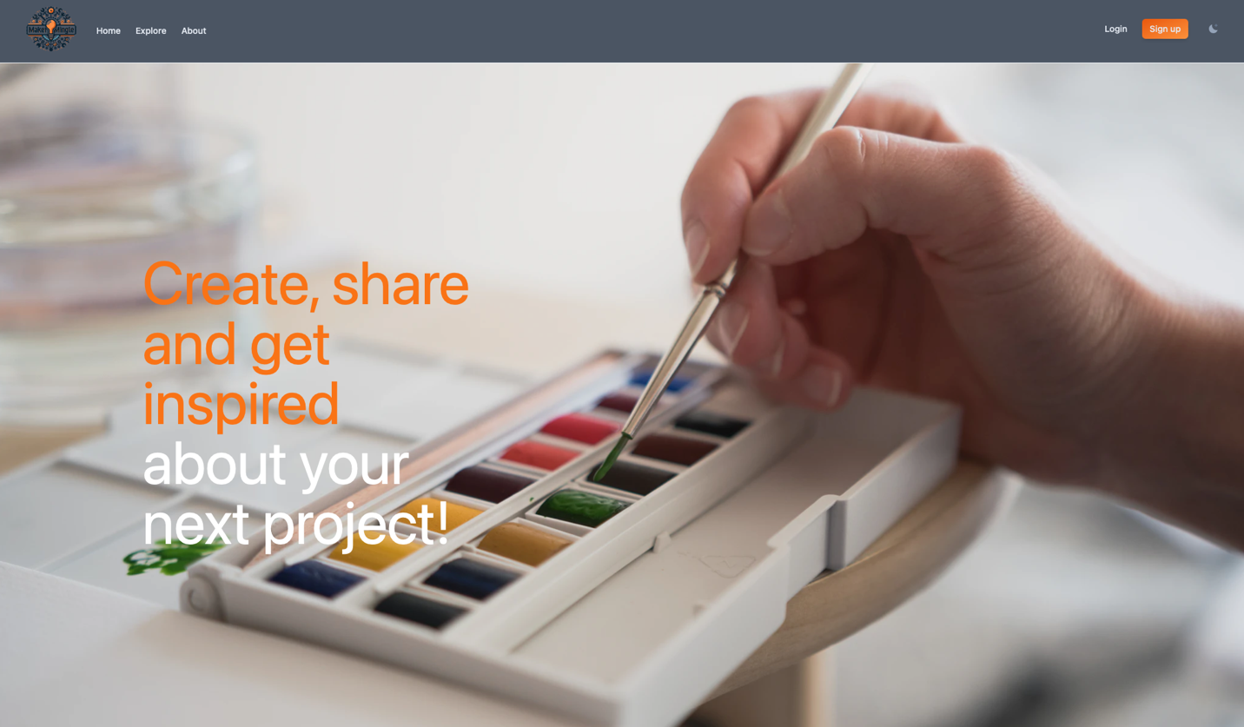

### Exploring Categories

**Step 1:** Click on the 'Explore' tab in the navigation bar.

**Step 2:** View the list of DIY categories presented as tiles. Choose a category by clicking on it.

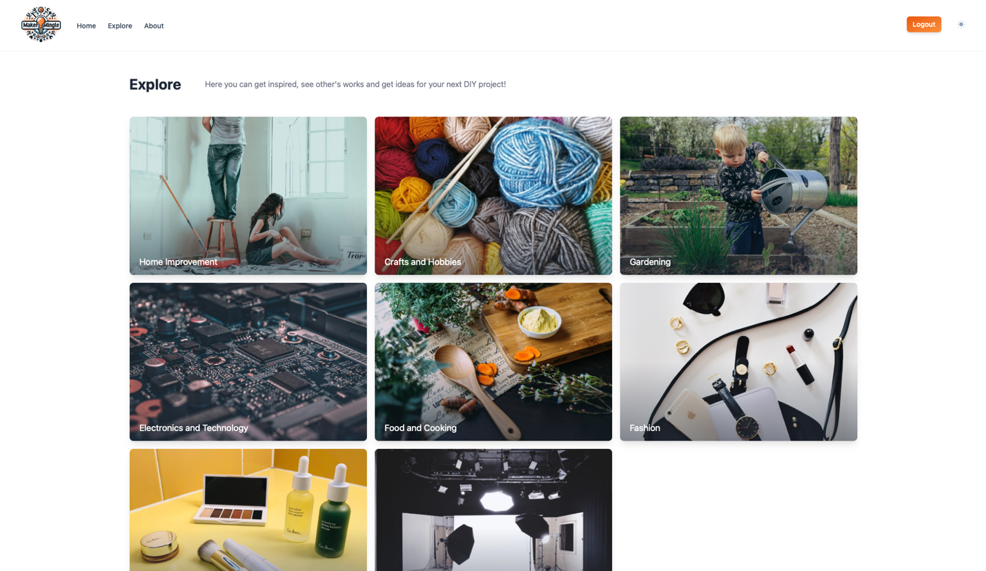

### Viewing Post

**Step 1:** Once in a category, browse through the tiles of posts.

**Step 2:** Click on any post to open its detailed page.

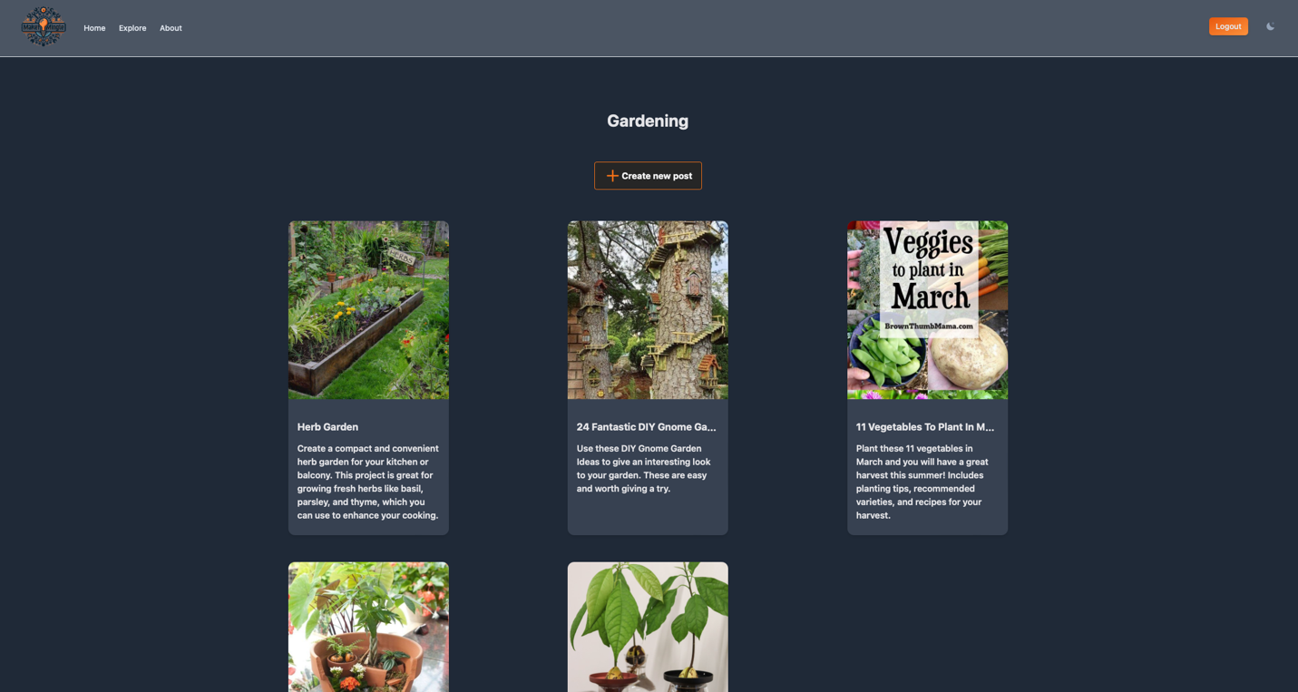

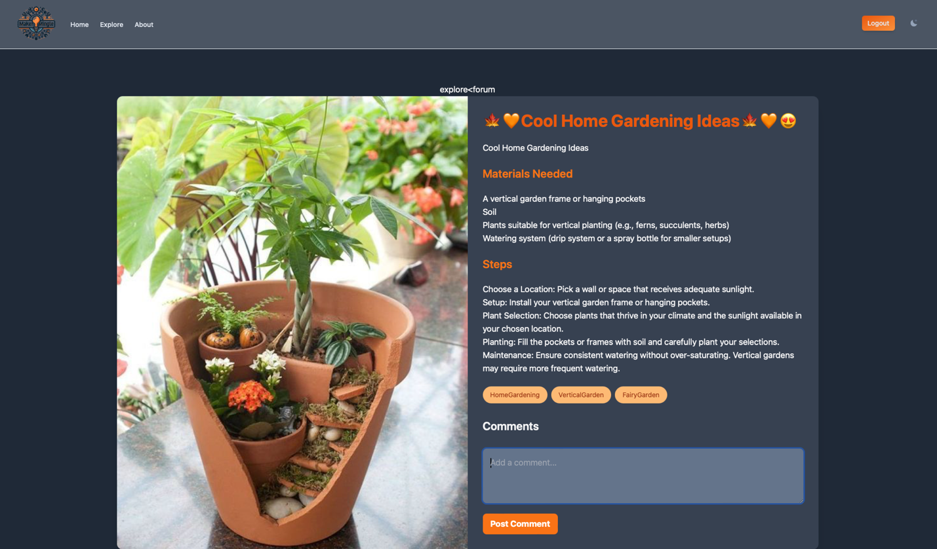

**Comment on a post:**

**Step 1:** On the Post Page of a selected project, scroll to the 'Comments' section at the bottom.

**Step 2:** Type your comment in the text box and click 'Post Comment'. Ensure you are logged in to use this feature.

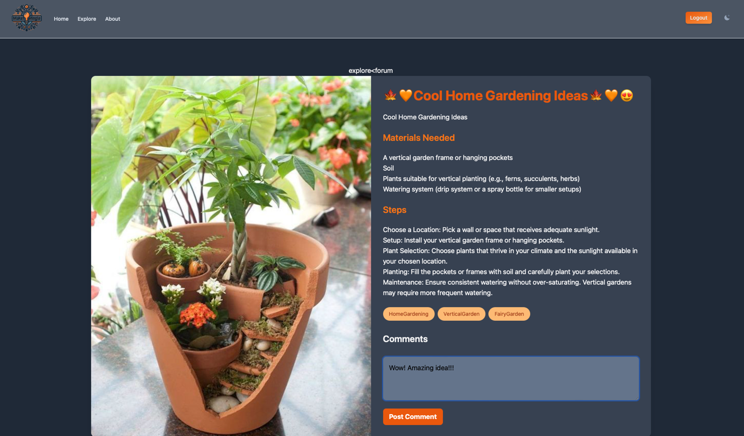

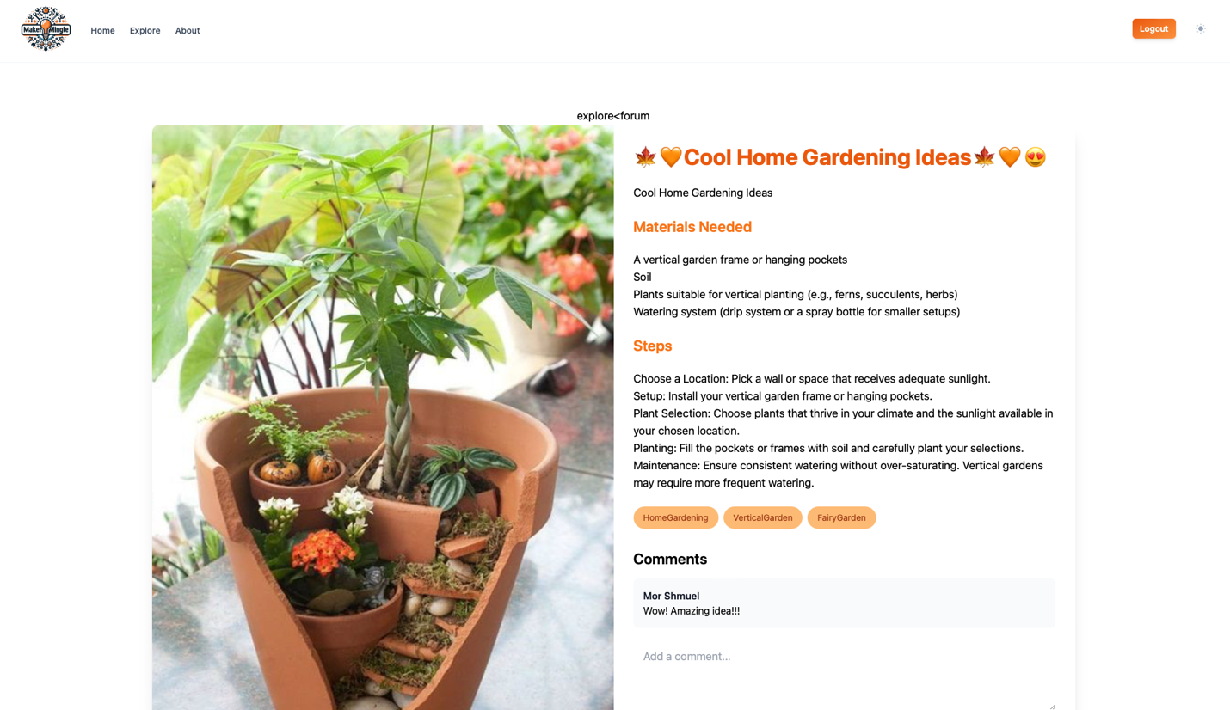

### Creating a Post

**Step 1:** Navigate to the Posts Page of the desired category.

**Step 2:** Click on the 'Create Post' button, accessible only to logged-in users.

**Step 3:** Fill out the form with the post title, description, description of the process, upload image, and list materials and steps.

**Step 4:** Click 'Post' to post your DIY project.

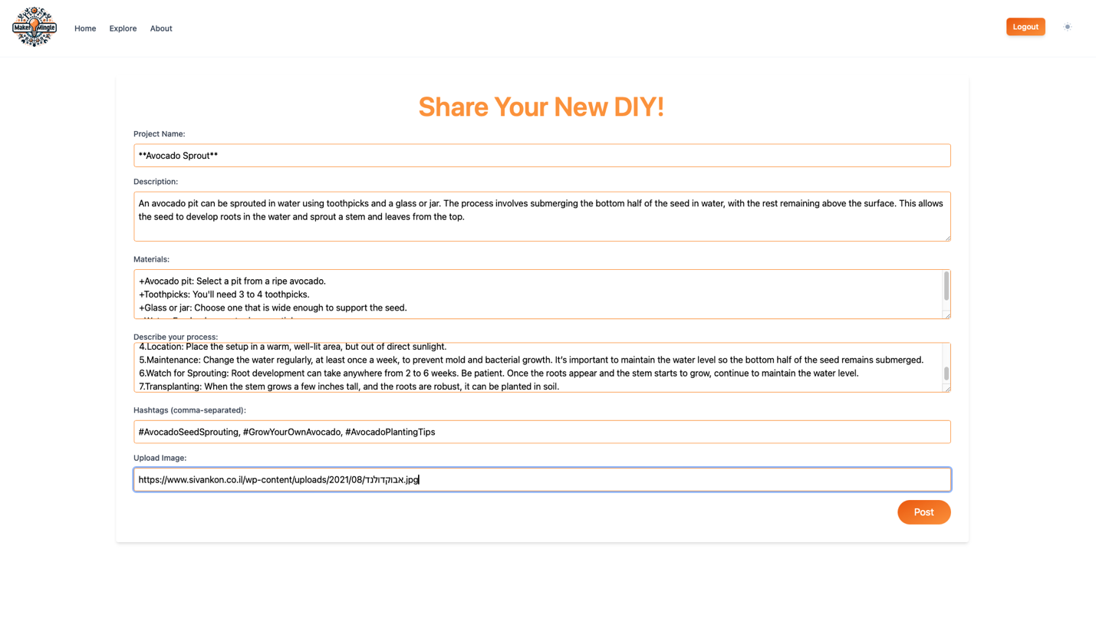

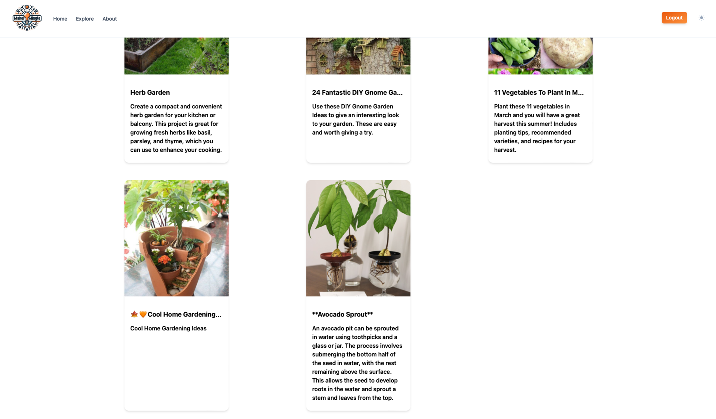

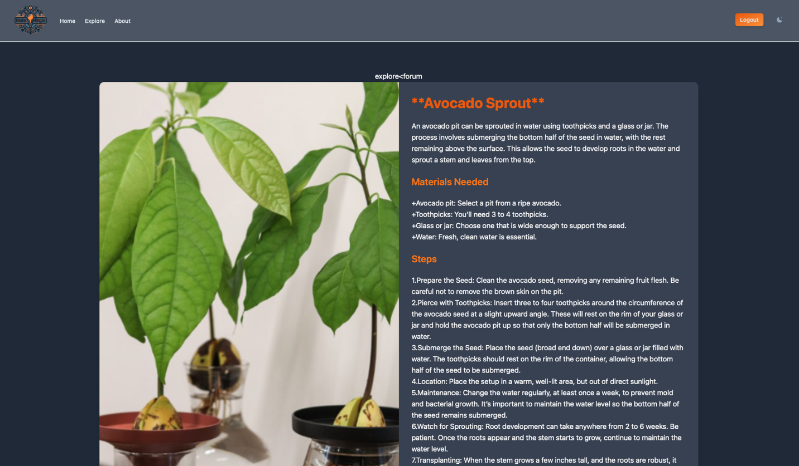

### Learning About the Website

**Step 1:** Click on the 'About' tab in the navigation bar.

**Step 2:** Read through the content to learn more about the mission, the creators, and the background of MakerMingle.

